Menu Screen Capture

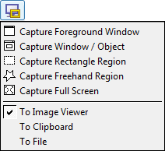

Figure 1: Menu screen capture

*Note: this is just an example. Replace it with appropriate diagrams*